|  |
| --- |
| **ChadList NoBrainNoPain** |

**Group Members:**

Tomás Gres (315185),

Dragos-Daniel Bonaparte (315261),

Dan-Sebastian Ceapa (315162),

Chiril Luncasu (315171),

Matas Armonaitis (315263)

**Supervisors:**

Jakob Knop Rasmussen (JKNR)

Joseph Chukwudi Okika (JOOK)

**

**[Number of characters]**

**Software Engineering**

**3rd Semester**

**17 / 12 / 2022**

**Table of content**

Abstract iii

1 Introduction 1

2 Analysis 2

2.1 Requirements 2

2.2 Functional Requirements 2

2.3 Non-Functional Requirements 3

3 Design 4

4 Implementation 5

5 Test 6

5.1 Test Specifications 6

6 Results and Discussion 7

7 Conclusions 8

8 Project future 9

9 Sources of information 10

10 Appendices 1

**List of figures and tables**

Optional

# Abstract

A small startup business called ChadList entered the market with an ambitious vision towards the 12th United Nations Goals (Anon., 2022c), to be precise, Responsible consumption and production. The startup offered research in terms of the waste generated worldwide and got to an alarming conclusion that there is about 53.6Mt of e-waste in 2019 alone (Anon., 2022b), around 17Mt of textile waste only in 2018 (Anon., 2022e) and in 2017 the furniture waste generated by Americans was 12.2Mt (Anon., 2022a). Their approach to the problem was to offer people an easy and efficient way to sell or offer their unused items to other people that can make use of them. The startup’s ideas and concerns were thereafter discussed with the Product Owner and the stakeholders to agree on a common and realistic vision of how the service will function. After which 22 functional requirements were selected carefully.

From the requirements given, the system will be composed of a simple set of actors, authenticated users, and unauthenticated users. Those requirements represent the main functionalities that can be performed by the aforementioned actors: creating a user which after will require the user to log in, once logged in, a user can create an item post and add images to it, and the marketplace can be accessed by either of the actors, an authenticated user is required to start a message with the seller, while the unauthorized user must rely on the phone number or email address, a user can edit his/her account, a user can edit an item and or change its status to sold or available.

The distributed system is composed of a 3-tier architecture which will offer faster development, improved scalability, improved reliability, and improved security making it clear, secure, and easy to maintain (Anon., 2022f). This layered architecture will allow the service to function everywhere regardless of location, making it more accessible to the end user. The system is presented as follows: The first tier, also known as the presentation tier is represented by a C# implementation of Blazor representing the user interface and it will be the tier that the end-user will interact directly with. The second tier will be the Business Logic Tier representing our middleware tier implemented in C# that will make sure that the third tier will be able to communicate back and forth with the first tier, but they must not communicate directly with each other creating a security flaw in the system. The third tier also known as the Data Access Tier is written in Java and will serve as the persistence which is connected to a database created in PostgreSQL. The first and second tiers communicate through Representational State Transfer also known as REST, while the second and the third tier will communicate through Remote Procedure Call open sourced by Google also known as gRPC.

To assess the quality of the product, the team used both Black boxing and White boxing testing. The tests written conclude that the product proves to meet the requirements and the main ideas of the stakeholders and the Product Owner.

# Introduction

Our customer is a Non-profit organization that focuses on waste management. It has decided to enroll in the competition between recycling and wasting, hoping that their approach will motivate people to waste less and make use of items for longer. We were contacted by the company with the offer to develop a system which would help its users to sell and exchange their belongings which they no longer need.

The issue most secondhand websites like eBay and Craigslist is that it is not available worldwide, and in consequence the end users who would actually benefit from the service are excluded (Anon., 2022d). Another aspect that the startup wanted to address is the need for a authenticated user when buying an item. While Facebook Marketplace addresses the problem with worldwide coverage, it lacks the anonymity for its users, requiring the end user to have an account before using the service which is something inconvenient for the user, especially if the user uses the service to only buy items.

The business owner decided

The purpose of the introduction is to provide background information and set the scene for your project. Within which business or organization are you doing the project? Who are the stakeholders and who is the customer?

The background information is adapted from your project description where you have already described the problem domain. Describe the current situation and existing context. Your statements must be supported by references to reliable and relevant sources.

This should lead to why this project is relevant and outline your aim and objectives. Which technical problems and challenges will be presented in this report, again taken from your project description. System illustrations and rich pictures are welcome here.

State delimitations relevant for your project in the introduction. Delimitations include what the project will not cover in relation to your project description, i.e. what could have been expected in your project. Remember that you can only make delimitations to aspects mentioned in the project description and you must argue well for your delimitations.

The last sentences of the introduction should be an overview of the sections to follow. This will be a good transition to the next sections.

Remember: You must ensure a clear connection between sections in the project report, from Project Description, Analysis, Design, Implementation to Test. This means that everything that is implemented can be found in design, everything that is designed is based on the analysis, and anything that is found in analysis has a clear link to requirements, etc.

# Analysis

The purpose of ChadList is to reduce wasting of reusable items throughout the world by giving everyone access to a platform, where they can sell and buy those items quickly and without any fees.

The system will have two types of users: regular users and administrators. Regular users will be able to sell and buy items and report to Administrator if an item that is being sold is forbidden from selling on the platform or if there was a problem with the seller or buyer during a transaction. The Administrator can then decide to ban the post and user being reported.

## Functional Requirements

## 

### Critical Priority

1. As a user I want to register, by specifying my first name, last name, phone number, email, date of birth and gender and log in specifying the email and password I used for the registration, in order to access my account.
2. As a user I want to be able to post an item for sale specifying its name, description of the item, price, currency and status of the item, in order to sell an item I don’t need anymore.
3. As a user I want to message the user over an item they are selling in order to negotiate and ask details about the item.
4. As a user I want to be able to search for a specific item specifying the part of name, part of the description and min and max price in order to find an item that I am looking for.
5. As a user I want to be able to view details of a specific item in order to decide about the purchase.
6. As a user I want to be able to see all my notifications in order to keep track of messages and item updates.
7. As a user I want to be able to see all my active and previous chats with the sellers, to be able to verify information between what the seller said and what the item is about.
8. As a user I want to be able to report an item in case the item does not respect the rule about forbidden items.

### High Priority

1. As a user I want to be able to edit my profile in order to modify any information that became outdated.
2. As a user I want to be able to delete or edit an item, in case I did any mistake during posting or I decided not to sell the item, or I sold the item.

### Medium Priority

1. As a user I want to be able to have a list of items that might interest me in order for me to find better items.
2. As a user I want to be able to add an item to my wish list in order to save items that I am not sure yet that I want.
3. As a user I want to get a notification whenever there is an update on an item in my wish list in order to be up to date about my saved items.
4. As a user I want to be able to see the sellers rating in order to see if he is a trustable person.
5. As a user I want to be able to comment/rate a seller to help other users trust the seller or not.
6. As a user I want to be able to see a seller’s profile in order to see any details that interest me such as address, rating or the amount of sold products.
7. As a user I want to be able to delete items from my wish list, in order to remove items that do not interest me anymore.
8. As a user I want to be able to change the password so that I don’t get locked out of my account.
9. As a user I want to be able to delete my account in case I do not want to use the service anymore.

### Low Priority

1. As a user I want to be able to sort the items by categories, in order to find what interests me.
2. As a user I want to be able to track how many people added a specific item to their wish list for me to take a faster decision about the item.
3. As a user I want to be able to see related items when I look at a specific post, in order to have a better chance of getting a better deal.

## Non-Functional Requirements

1. The system must be able to work on Mozilla Firefox v106.0 and previous, Google Chrome v107.0 and previous and Microsoft Edge 107.0 and previous

## Actor Description

### User can sell items on the platform as well as search for items they would like to buy and contact other users in order to buy them. Users can also report items and users if the items they are selling are banned on the platform or if the transaction did not go as agreed.

**Administrator** can look at the reports from users and decide depending on the reports to either ban the post or the post and the user from the platform.

## Use Case Diagram

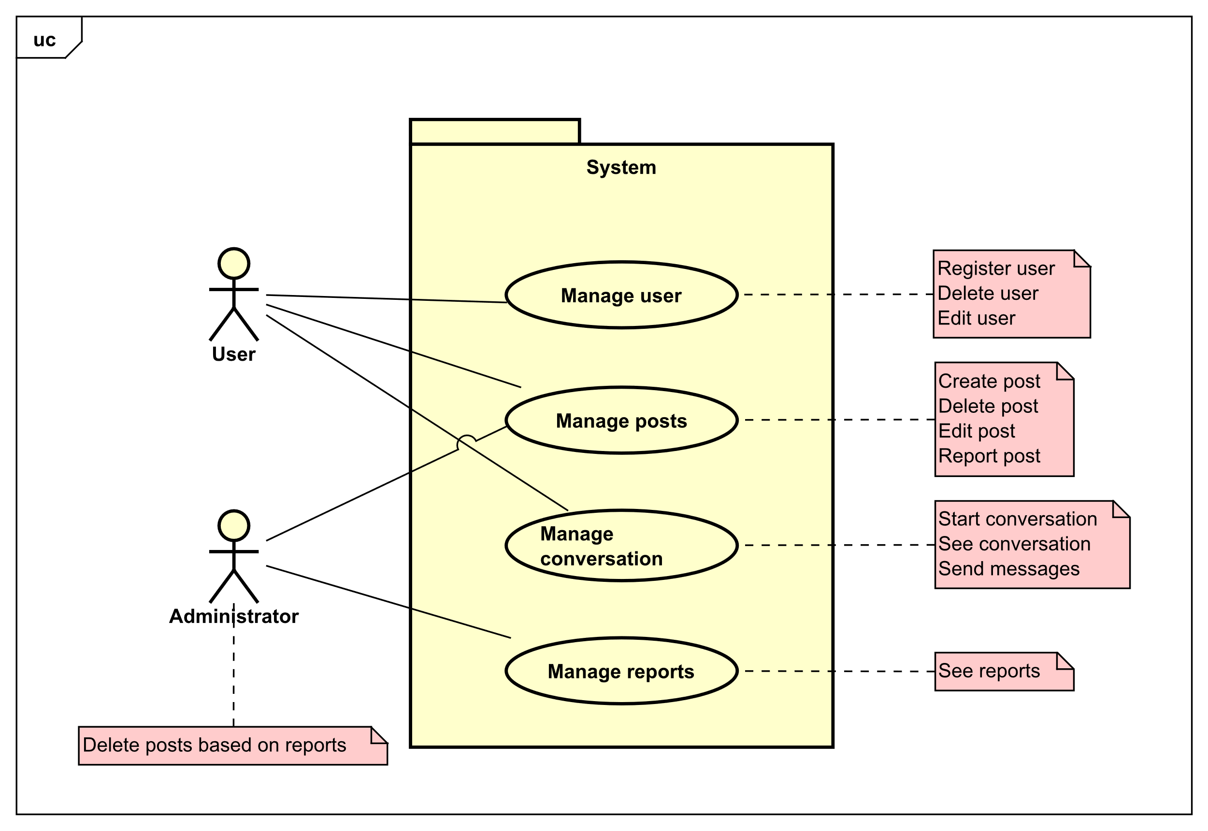

Figure 1 – Use Case Diagram

## Use Case – Brief Description (Manage Posts)

**Manage posts** – A user will need an account to access most of the functions. The user presses the new post button and starts introducing all the necessary information required to create a post. Another user logs on to the website, sees the post and starts talking to the seller. The user ends up buying the product, and goes to the seller’s profile, writes a nice comment, and gives the seller a positive rating. Now the seller goes to his post marks it as SOLD or deletes the post entirely so that he won’t be contacted again for a product he sold.

## Use Case – Fully Dressed Description (Manage Posts)

|  |  |
| --- | --- |
| Use Case | Manage posts |
| Summary | The user creates new posts with items, updates and deletes them |
| Actor | User |
| Precondition | The user must be logged in. For delete and update, user has to have created at least one post |
| Postcondition | The post will be created, updated or deleted |
| Base scenario | Create a post   1. User logins to his account. 2. User presses the marketplace button. 3. A window will be shown with all items that are for sale and their description. 4. If the user wants to sell an item, he needs to press the add post button. 5. A window will be shown, where the user can add all the necessary information about the item or edit it.   Delete Posts   1. User deletes the post by pressing the edit button. 2. A window will appear will all the information about post, and a delete button below.   The user presses the delete button and the post will be deleted |
| Alternative scenario |  |
| Exception | If one of the fields or more are empty, an error will be shown. |

## Activity Diagram (Manage Posts)

## System Sequence Diagram

## Domain Model

A **User**, after registering and creating an account and providing their **Address**, can decide to sell their **Item** (things they own and do not need anymore). After that, another **User**s can save the item to their **Wishlist.** If they wish to buy that item, they can start a **Conversation** with them to negotiate the price and delivery by sending a **Message**. After a message is sent, the seller will get a **Notification**. If an **Item** which is not legal to sell, is posted on the platform, another users can **Report** them and the **Administrator** can then ban the **User** and delete the **Item**.

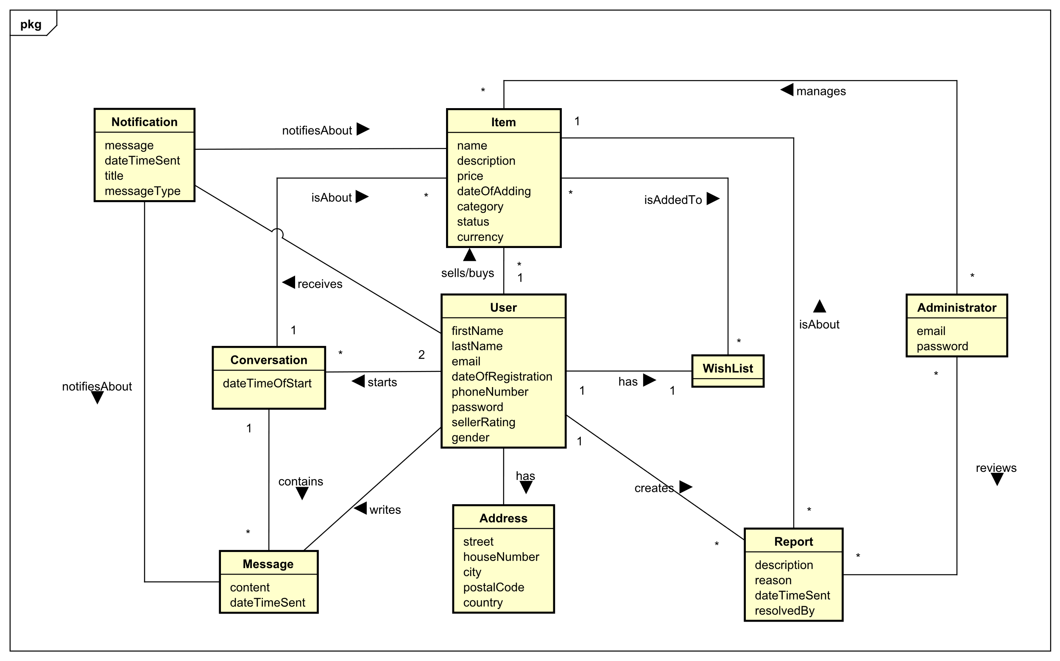

# Design

The team has decided to split the system into 3 tiers. The decision to choose 3 tier architecture over regular client server application had many different reasons. One of the reasons was that if the client decides to change the database provider to another in the future, the application tier will not have to be changed. Another reason was easier testability of each tiers, because they are separated, we can test business layer, without relying on presentation layer working.

## Presentation Tier

The presentation tier will be mainly responsible for interaction with the users. The technology used for the presentation tier is Blazor WASM and C#. The tier will fetch data from and send data to the business tier using REST Web API and HTTP protocol.

## Business Tier

The business tier will be responsible for handling user requests and responses. The technology used for this tier is C# and .NET 6.0. The tier will communicate with the database tier using gRPC.

## Database Tier

The database tier will be responsible for storing user data. The technology used for this tier is Java 17, JPA/Hibernate and PostgreSQL.

Elements that may be relevant in this section:

* Architecture: Find architecture patterns here (Leszek Maciaszek 2004, chap.9).
* Technologies: Describe technologies used, also alternative technologies. Argue for choice of technology according to the project aim.
* Design Patterns: Describe which design patterns (GoF (Gamma et al. 2002) etc.) you are using and why.
* Class Diagrams
* Interaction Diagrams
* UI design choices
* Data models, persistence, etc.

You must explain all diagrams in the report. These diagrams including descriptions are the blueprints for the implementation.

Hint: One way to figure out which objects/classes are needed in the design is to apply the General Responsibility Assignment Software Patterns/principles (GRASP) (Larman 2004, chap.17).

Hint: Consider how to design your system to make it testable.

# Implementation

The purpose of the implementation section is to explain interesting code snippets. An idea is to explain the complete path through your system from UI to database etc.

Remember that your implementation must be consistent with your design (Larman, 2004, chap.20).

Which standard libraries are used? How are design patterns implemented, etc.

Hint: Implement your code in a testable manner.

# Test

To make sure that software the Product Owner expects is working, the software was tested every sprint. The test included some unit tests and some manual testing.

## Test Cases

The manual testing was a crucial tool to make sure that everything in the system works as intended and the tiers cooperated with each other the way they were intended. The tests were created based on use case descriptions. For each implemented description a test was done to make sure it is implemented correctly. For these tests we used black box testing.

## Business logic tier/Data Access tier tests

In order to test both tiers it was decided to make the tests in the business tier, but to also use the database server from data access tier for testing some of the use cases. Once again use case descriptions were used to create the test cases. This allowed to see when adding additional implementation if there were any bugs that influenced some of already completed use cases without the need for interacting with the presentation tier. Xunit library was used for these tests. Text

## Unit tests

Because of the amounts of manual testing, testing in other tiers and the difficulty of automated tests, the development team decided to only implement necessary tests for the presentation tier. The tests are made to work without being dependant on other tiers, meaning it required mocking and quite a bit of research in order to make them work. Only necessary tests for the presentation tier to work were implemented in order for the development team to fit in to the time schedule.

Bunit and Nunit.autofixture frameworks and white box together with aaa(Arrange, Act, Assert) strategy was used to implement the unit tests. Bunit allowed to make the tests independent from the other tiers and autofixture allowed us to input random data without the need of manual input. In total 3 Tests for the presentation tier were implemented, which all passed in the end. In order to keep other more simple units like setters and getters working properly, manual testing was used throughout all of the sprints.

# Results and Discussion

The purpose of the results and discussion section is to present the outcome and achieved results of the project.

# Conclusions

The purpose of the conclusion section is to compile the results from each section in the report. What is the conclusion? Did the project fulfil the requirements? Etc.

You can only comment on report contents, no new topics or content can be introduced in this section.

# Project future

Reflect on your project from a technical viewpoint and describe what you would change if you could.

Suggest how the project could be improved or made ready for production. Discuss scalability, suggest possible spin offs, what is needed, missing, etc.?

# Sources of information

**Note: Use the standard reference method: Harvard Anglia. A very good reference tool is Mendeley** (Mendeley.com, 2016), **ask VIA Library if you need help.**

Banger, D., 2014. A Basic Non-Functional Requirements Checklist « Thoughts from the Systems front line.... Available at: https://dalbanger.wordpress.com/2014/01/08/a-basic-non-functional-requirements-checklist/ [Accessed January 31, 2017].

Business Analyst Learnings, 2013. MoSCoW : Requirements Prioritization Technique — Business Analyst Learnings. , pp.1–5. Available at: https://businessanalystlearnings.com/ba-techniques/2013/3/5/moscow-technique-requirements-prioritization [Accessed January 31, 2017].

Dawson, C.W., 2009. *Projects in Computing and Information Systems*, Available at: http://www.sentimentaltoday.net/National_Academy_Press/0321263553.Addison.Wesley.Publishing.Company.Projects.in.Computing.and.Information.Systems.A.Students.Guide.Jun.2005.pdf.

Gamma, E. et al., 2002. *Design Patterns – Elements of Reusable Object-Oriented Software*, Available at: http://books.google.com/books?id=JPOaP7cyk6wC&pg=PA78&dq=intitle:Design+Patterns+Elements+of+Reusable+Object+Oriented+Software&hl=&cd=3&source=gbs_api%5Cnpapers2://publication/uuid/944613AA-7124-44A4-B86F-C7B2123344F3.

IEEE Computer Society, 2008. *IEEE Std 829-2008, IEEE Standard for Software and System Test Documentation*,

Larman, C., 2004. *Applying UML and Patterns: An Introduction to Object-Oriented Analysis and Design and Iterative Development*,

Mendeley.com, 2016. Homepage | Mendeley. Available at: https://www.mendeley.com/ [Accessed February 2, 2017].

YourCoach, S.M.A.R.T. goal setting | SMART | Coaching tools | YourCoach Gent. Available at: http://www.yourcoach.be/en/coaching-tools/smart-goal-setting.php [Accessed August 19, 2017].

# Appendices

The purpose of your appendices is to provide extra information to the expert reader. List the appendices in order of mention.

Examples of appendices

* Project Description
* User Guide
* Source code – source documentation
* Diagrams
* Data sheets
* Etc.

**Appendix A Project Description**

Insert the original Project Description here